**ASSIGNMENT 7.2**

PRBOLEM STATEMENT:

**1)** **Write a Hive program to find the number of medals won by each country in swimming.**

Query:

select country, sum(total) from olympic where sport=”Swimming” group by country;

Output:

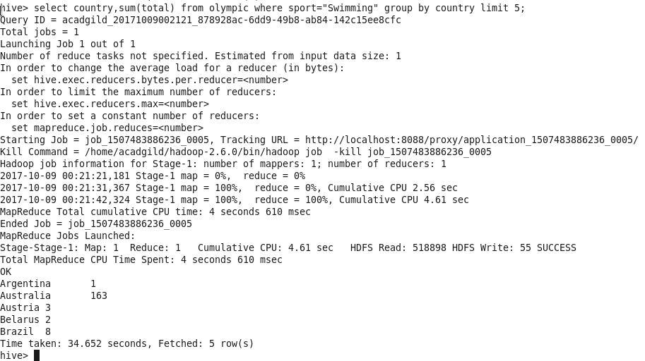

**2)** **Write a Hive program to find the number of medals that India won year wise.**

Query:

select year, sum (total) from olympic where country=”India” group by year;

Output:

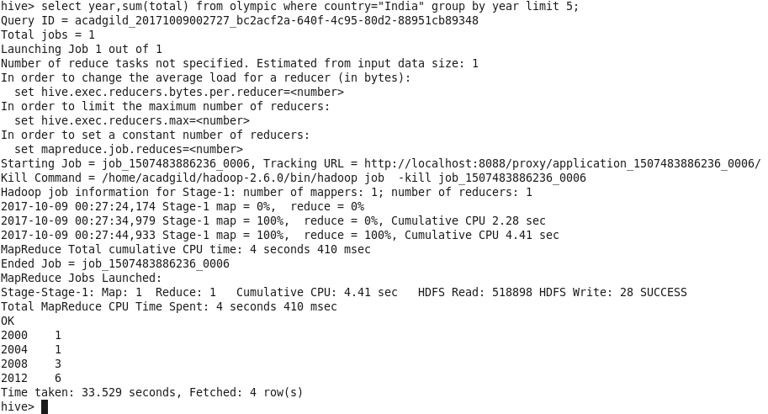

**3)** **Write a Hive Program to find the total number of medals each country won.**

Query:

select country, sum(total) from olympic group by country;

Output:

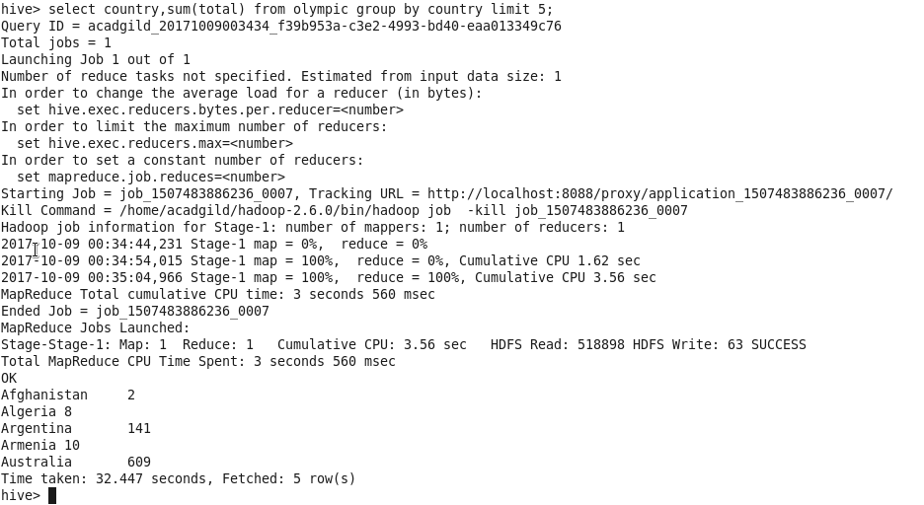

**4)** **Write a Hive program to find the number of gold medals each country won.**

Query:

select country, sum(gold) from olympic group by country;

Output: 